Name _________________________________

Watch the video and write down or draw…

3 Insects You See

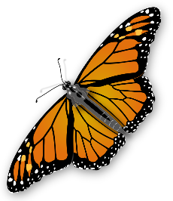

2 Plants You See

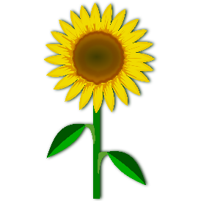

1 Other Observation